

**Faculty of Computing**

**Department of Computing & Information Systems**

**ASSIGNMENT 1**

**IS5105 – Business Process Management**

Group 02

20APC4551 - A.S. Ambagahawatta

20APC4577 - M. Shakishnavi

20APC4615 - J. Lakchika

20APC4897 - J.R.N. Theeksha

20APC4900 - K.P.T.S. Ranasinghe

20APC5037 - K.S. Dilrukshi

20APC5043 - E.N.V. Lakmali

**Phase II**

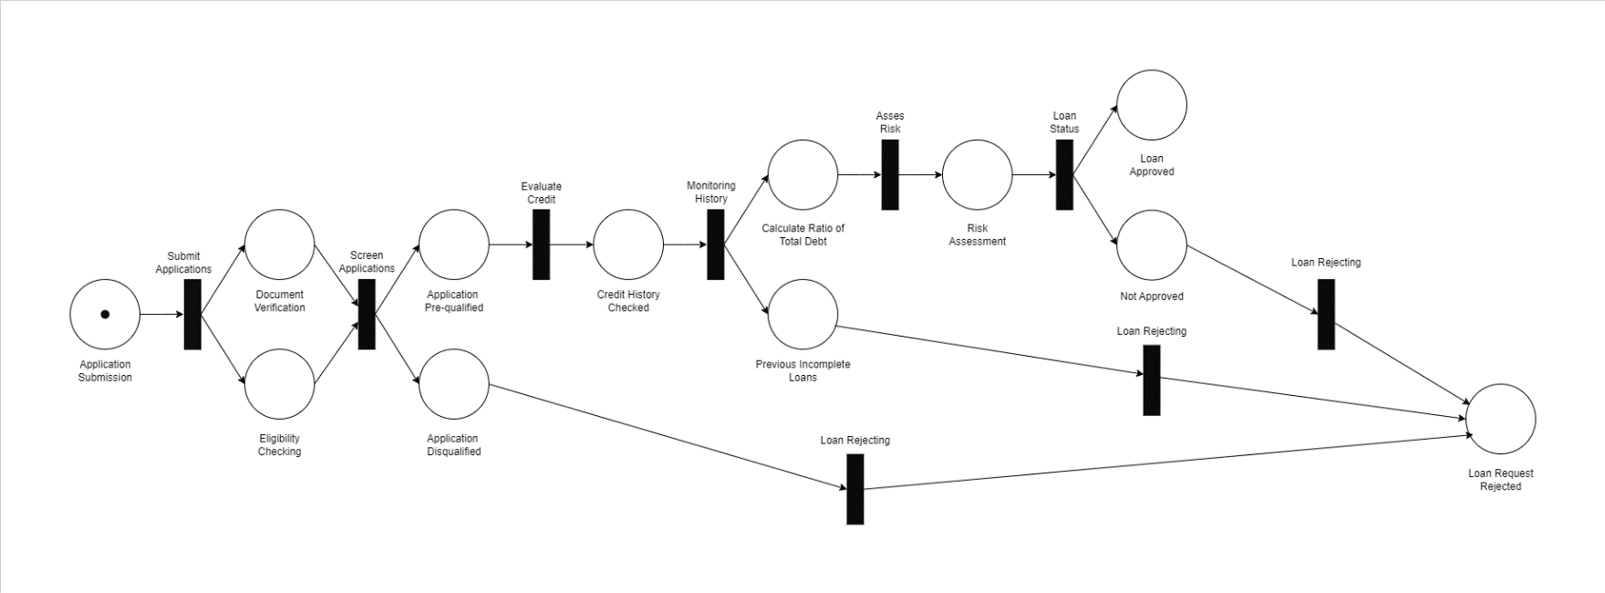**Petri net Modeling**

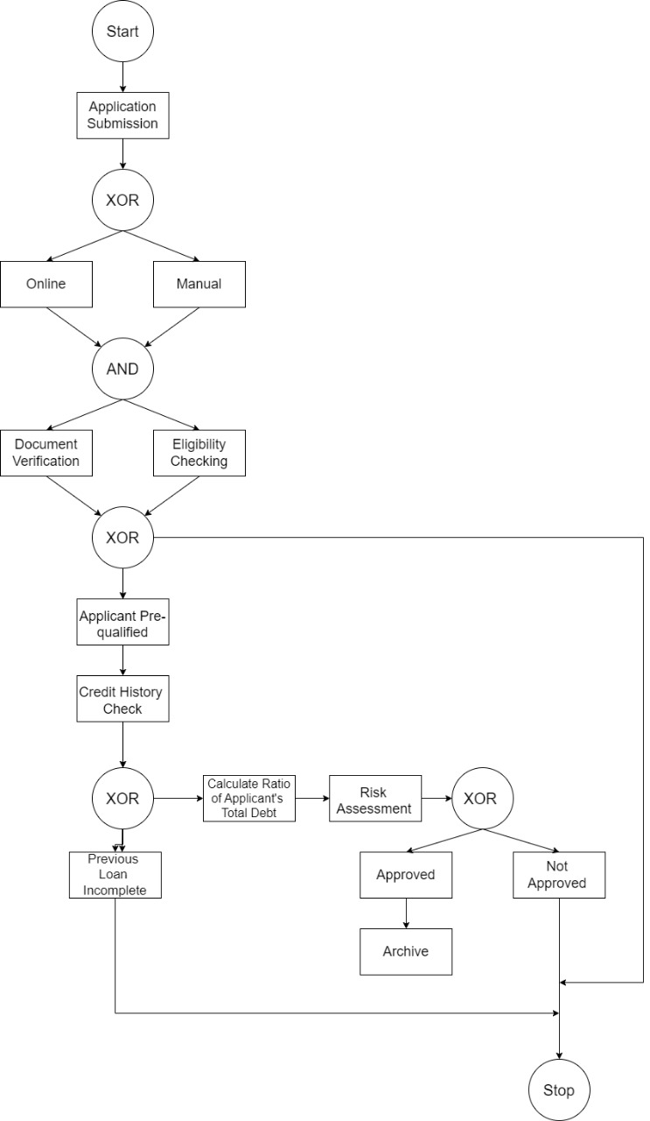**2. Book Notation Modeling**

**3. Verifying Business Process Using Book Notation**

Reachability Graph

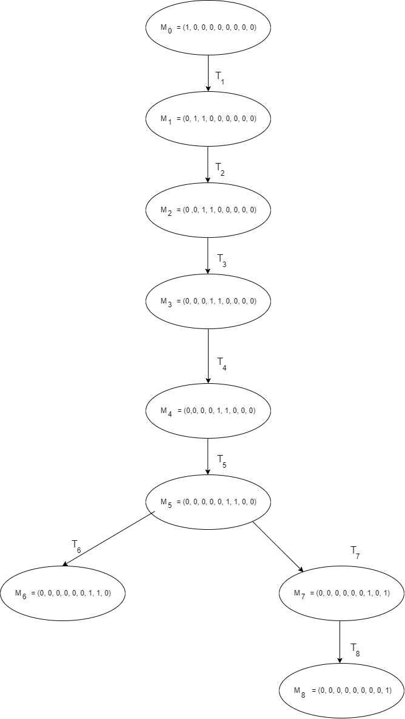

T1: Submit Applications

T2: Screen Applications

T3: Evaluate Credit

T4: Monitoring History

T5: Assess Risk

T6: Loan Status (Approved/Not Approved)

T7: Loan Rejecting

Each of these transitions represents a step in the business process model, showing how an application moves through the various stages from submission to approval or rejection.

Coverability Graph.

As noted in the document, the coverability graph is identical to this model's reachability graph. This indicates that the system does not have any places with potentially unbounded resources, and all states are finite and can be explicitly represented in the reachability graph.

The business process verification through these graphs ensures that all possible states and transitions are accounted for, thoroughly analyzing the system's behavior and identifying any potential issues or inefficiencies.